1. write and run the programs using notepad and cmd
2. submit your .java code along with screenshot of output
3. do not submit rar/zip file
4. current path of cmd must include your roll no

Task - 01:

Define a class to represent a student. Include the following members
Data Members (all attributes must be private):
Student's First Name
Student's Last Name
Student's Roll Number
Major
Number of Credits Completed
Total Credits Required
GPA
Member Functions:
Setters and Getters: To set and get all attributes.
Calculate GPA: To compute the GPA based on completed credits and total credits required.
Display Details: To show the student's first name, last name, roll number, and GPA.
Note: You must ask the user to input the values

Task - 02:
Create a class Teacher with the following private attributes:
- Name
- Age
- Institute
Derive three classes from it that has Create a class Teacher with the following private attributes:
- Employee ID
- Email
- Phone Number
Derive three classes from it with the following names: HumanitiesTeacher, ScienceTeacher, and MathsTeacher. Each of these derived classes should have the following members:
- Specialization (e.g., "Literature", "Physics", "Algebra")
- Years of Experience
- Research Interests (e.g., "Ancient History", "Quantum Mechanics", "Calculus Applications")
Each class should include:
- Proper accessors (getters) and mutators (setters) for all attributes.
- A method to display all relevant information about the teacher.
Requirements:
- Define the Teacher class with private attributes and appropriate setters and getters.
- Define each of the derived classes (HumanitiesTeacher, ScienceTeacher, MathsTeacher) with additional attributes, including setters and getters.
- Implement a method in each class to display the values of all attributes.
- Create objects for each of the derived classes.
- Prompt the user to input the values for each teacher's attributes.
- Display the values using the method implemented in each class.

Task - 03:

A defense organization is making an hierarchy of different types of weapons. They have classified the nuclear bomb as follows:
Weapons → Hot Weapons → Bombs → Nuclear Bombs
Create classes and apply inheritance as necessary for the above hierarchy.
Each class should have a method called: “xxxxxDescription”, where xxxx would be class name.
The method should print out what that weapon does. Eg. Hot weapons uses gunpowder, or explode. Bombs blow up. Nuclear bombs blow up, and use nuclear fission and fusion.

Task - 04:

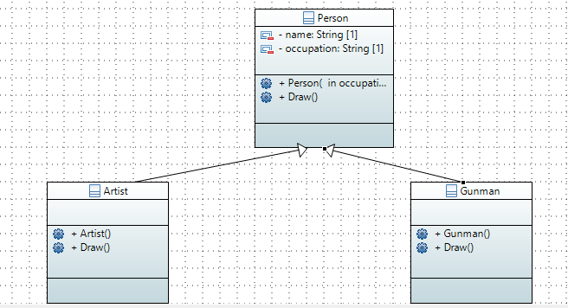
Create the classes following the diagram shown. Keep the following things in mind:
- When an object of Artist is created, the value “artist” will be set to occupation.
- When an object of Gunman is created, the value “gunman” will be set to occupation.
- Person::Draw() will print out “A person can draw in many ways”
- Artist::Draw() will print out “An artist can draw with a paint brush”
- Gunman::Draw() will print out “A gunman draws a gun to shoot”

